**Adding Incentive system to the App.**

In the marketing world, an “incentive” is something that motivates an individual to perform an action, such as making a purchase, completing a survey or signing up for a mailing list. In other words, it’s an “enticement” to get customers and prospects to do what you want them to do, so in our case incentives will play a critical role in encouraging users to participate more in the app, and help others in services.

**Our incentive system consists of two types of incentives:**

**1-Givantk points.**

**2-Money Score.**

1-Givantk points are points that helpers take for helping in free services, they may exchange it later to discounts in stores.

**To know how givantk points work, we will discuss the following example:**

*“User A registered in the app, and he will find that he has an amount of 100 givantk points in his account.*

*He can use them to order as much free services as he wants, any free service requires at least 1 givantk point. So he asked for a service with 10 points.*

*If User B helped User A in his service, and the service is finished successfully. User B will take the 10 points, and they will be added to his account.*

*User A account now will only has 90 points.*

*If he finished his points, he is encouraged to help in more free services to get more points, but he can also get a random number of points if he wants to ask for new free service, but this random number of points will not exceed 10 points*.”

2-Money Score: this score is equivalent to the real money that the user charges his account by.

**And here’s an example to the way that is used in our app:**

*“User A wants to ask for a paid service, he initially doesn’t have any money in his account in the app, so he goes to his account tab and charge it with visa or Vodafone cache, then his money appears in his account.*

*User A asks for a service for 100 EGP, then the app takes a share of this price, and the service is being published for 91 EGP.*

*If no user is accepted in this service, User A can archive the service and take all his money back in his account (100 EGP).*

*If a user is accepted in this service, the money will be in hold until the service is finished.*

*If the service is finished successfully, User B takes 91 EGP.”*

**How all of these look in the app?**

1-**Here’s we ask the user for the nature and price of service before publishing it.**

Depending on his choice of the nature of the service the price will differs, if the user chooses free services, he will deal with money score, else he will deal with givantk points.

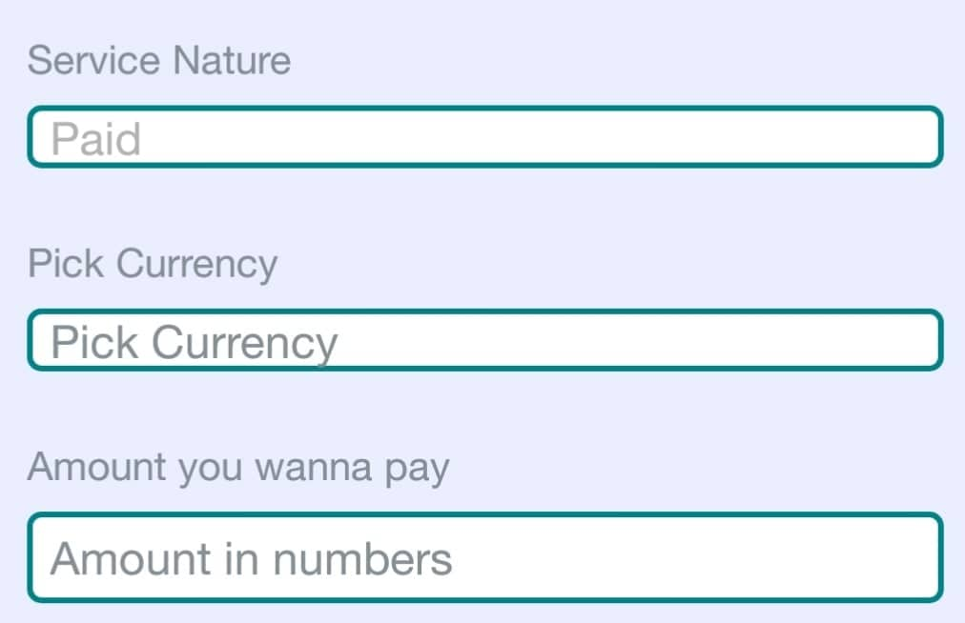

2-**Example for free services, and the number of points being displayed in the service card.**

So this will make it easy for the helpers to surf the services easily knowing how much exactly does each service cost.

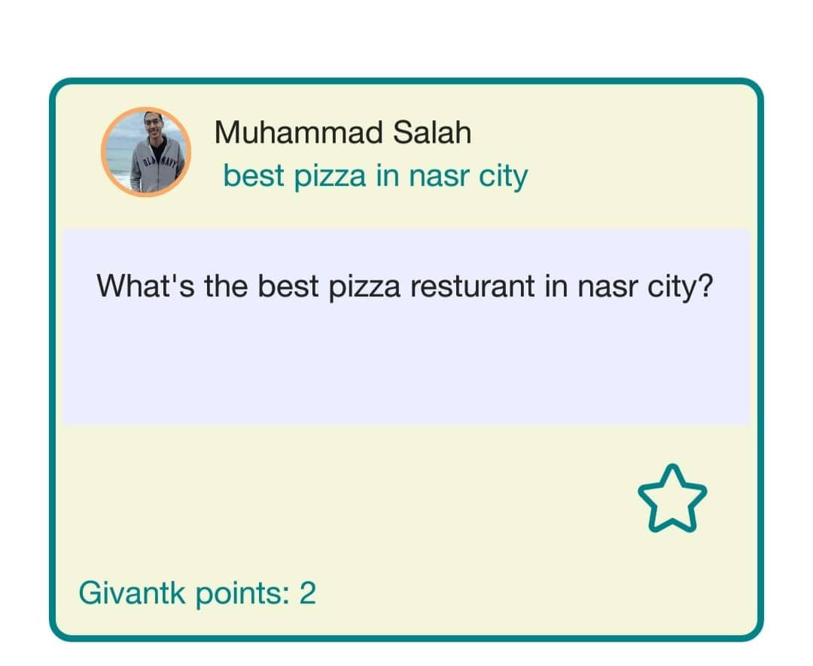

3-**Example for charging money score with money:**

This screen acts as an interface, where the user will enter the amount of money by which he wants to charge his account, and then the app deals with the payment gateway, and if it received a success token, the money will be added to the user account.

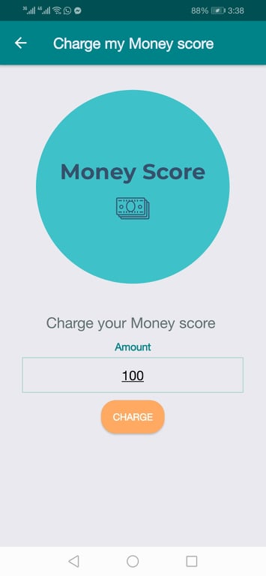

4-**Example for getting random number of givantk points:**

The point of making this is to make sure that users can always ask for free services, even if they have spent all their free points, also another thing to point out is that this adds the element of gamification to the app by getting the user excited about getting new random points.

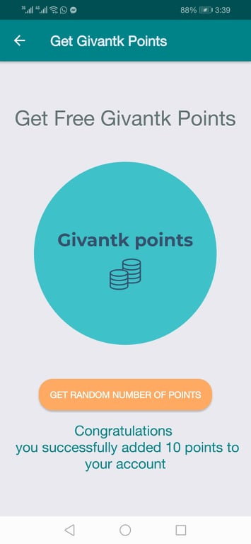

5-**Example of displaying givantk points and money score in the account tab:**

Note that the money score is displayed in the account screen only, but not in the profile, while givantk points (free points) are displayed inside the profile normally.

This ensures the privacy of the user, by hiding how much money score does the user have on the app.

